**Tour and Travel Web Guide**

**Course Name:** Web Technology Lab

**Students Name:**

1. Nayma Sultana (2154901072)

2. Amena Ansari Bela (2154901076)

3. Shubhanwita Dey Swasty (2154901078)

Dept. of Information and Communication Technology

Bangladesh University of Professionals

**Instructor Name:**

1. Dr. Md. Shamim Al Mamun

Professor, IIT, JU

2. Md. Shahiduzzaman

Assistant Professor, CSE, BUBT

**Submission Date:** 30.05.2024

**Abstract**

The Tour and Travel project is a comprehensive web application designed to streamline the process of booking travel services, including flights, hotels, and tour packages. Built using HTML, PHP, JavaScript, and CSS, this project provides a user-friendly interface and robust functionality for both customers and administrators. HTML and CSS are utilized to create a visually appealing and responsive design, ensuring compatibility across various devices. PHP serves as the backbone for server-side processing, handling user authentication, data storage, and retrieval from a MySQL database. JavaScript enhances user interaction with dynamic content updates, form validations, and AJAX calls for seamless, real-time communication between the client and server. Key features include a search engine for travel options, user account management, booking history, and an admin panel for managing services and reservations. This project aims to simplify travel planning, offering a convenient and efficient platform for users to manage their travel needs.

**Table of Contents**

**1. Introduction ............................................................. 3**

**2. Methodology ......................................................... 4**

**3. Design................................................................. 5**

**4. Implementation .................................................. 7**

**5. Result ................................................................. 9**

**6. Conclusion ......................................................... 14**

**7. References ......................................................... 15**

**Introduction**

The Tour and Travel project is a dynamic web application designed to enhance the travel booking experience by integrating various travel services into a single, cohesive platform. Developed using HTML, PHP, JavaScript, and CSS, this project aims to provide users with a seamless and intuitive interface for booking flights, hotels, and tour packages. The platform caters to both individual travelers and administrators, offering a range of functionalities to manage travel arrangements efficiently.

The primary purpose of the Tour and Travel project is to simplify the travel booking process, making it more accessible and user-friendly. With the growing demand for online travel services, this project addresses the need for a comprehensive solution that integrates multiple travel services into one platform. By offering a streamlined booking process, real-time updates, and secure transactions, the project significantly enhances the user experience. It also provides travel businesses with a tool to manage bookings, optimize customer service, and increase operational efficiency.

The scope of the Tour and Travel project encompasses the following features:

**1. User Interface:** Development of a responsive and aesthetically pleasing interface using HTML and CSS.

**2. User Authentication:** Secure login and registration system powered by PHP.

**3. Booking System:** A robust booking engine that allows users to search and book flights, hotels, and tour packages.

**4. Admin Panel:** A comprehensive admin panel for managing travel services, reservations, and user data.

**5. Dynamic Content:** Utilization of JavaScript to provide interactive elements, form validations, and AJAX-based real-time updates.

**6. Database Management:** Implementation of a MySQL database for efficient data storage and retrieval.

The Tour and Travel project contributes significantly to the travel industry by:

**1. Enhancing User Experience:** Providing a user-friendly platform that simplifies the booking process and improves customer satisfaction.

**2. Increasing Efficiency:** Streamlining administrative tasks and reducing the complexity of managing travel services.

**3. Promoting Accessibility:** Offering a comprehensive solution accessible from various devices, ensuring a wider reach.

**4. Facilitating Growth:** Enabling travel businesses to scale their operations and enhance service offerings through an integrated platform.

Overall, the Tour and Travel project aims to revolutionize the way people plan and book their travels, offering a one-stop solution that meets the diverse needs of modern travelers and travel businesses alike.

**Methodology**

The development process of the Tour and Travel project followed a structured approach, divided into several key phases to ensure a systematic and efficient workflow:

**1. Requirement Analysis:** Identifying the needs of the users and the functionalities required for both customers and administrators. This phase involved gathering requirements through surveys, interviews, and market research.

**2. Planning:** Developing a detailed project plan, including timelines, milestones, and resource allocation. Wireframes and prototypes were created to visualize the user interface and user experience.

**3. Design:** Designing the front-end interface using HTML and CSS to ensure a responsive and aesthetically pleasing layout. Concurrently, the back-end architecture was planned using PHP and MySQL.

**4. Development:** Coding the front-end and back-end components. HTML and CSS were used for the structure and styling, PHP for server-side logic, and JavaScript for interactive elements and AJAX functionality.

**5. Testing:** Conducting thorough testing to identify and fix bugs. This included unit testing, integration testing, and user acceptance testing to ensure the system met all requirements and functioned seamlessly.

**6. Deployment:** Launching the application on a web server, ensuring it is accessible to users. Post-deployment, continuous monitoring and maintenance were carried out to address any issues and implement improvements.

The following technologies and tools were utilized in the development of the Tour and Travel project:

**1. HTML:** For structuring the content and creating a semantic layout.

**2. CSS:** For styling and ensuring a responsive design across various devices.

**3. JavaScript:** For enhancing user interaction with dynamic content updates, form validations, and AJAX for real-time data fetching.

**4. PHP:** For server-side scripting, handling user authentication, and database interactions.

**5. MySQL:** For database management, ensuring efficient storage and retrieval of user and booking data.

**6. Apache:** As the web server for deploying the application.

During the development of the Tour and Travel project, several challenges were encountered:

**1. Integration of Multiple Services:** Combining flight, hotel, and tour package booking systems into one platform was complex. Solution: Modular development was employed, allowing each service to be developed and tested independently before integration.

**2. Ensuring Security:** Protecting user data and transactions was paramount. Solution: Implementing secure coding practices, including input validation, encryption for sensitive data, and using HTTPS.

**3. Responsive Design:** Ensuring the application worked seamlessly on various devices and screen sizes. Solution: Utilizing Bootstrap and responsive design techniques to create a flexible layout.

**4. Real-time Updates:** Providing users with up-to-date information on bookings and availability. Solution: Implementing AJAX for asynchronous data loading, ensuring the interface remains responsive while fetching data from the server.

**5. User Experience:** Creating an intuitive and user-friendly interface. Solution: Conducting usability testing and gathering feedback to refine the user interface and user experience continuously.

By addressing these challenges with effective solutions, the development process was streamlined, resulting in a robust and user-centric Tour and Travel application.

**Design**

The design of the Tour and Travel project is centered around creating a user-friendly, responsive, and efficient platform for booking travel services. The design process involved careful planning and the use of various models and diagrams to ensure a cohesive and intuitive interface for both users and administrators. The project design can be broadly categorized into front-end and back-end components, each with specific considerations for functionality and usability.

The front-end design focuses on the user interface (UI) and user experience (UX). HTML5 and CSS3 were used to create a clean, responsive layout that adapts seamlessly to different devices and screen sizes. Bootstrap was integrated to enhance the responsiveness and provide a consistent styling framework. JavaScript and AJAX were employed to add interactivity and real-time data updates, ensuring a smooth and engaging user experience.

The back-end design is driven by PHP and MySQL, forming the core logic and data management of the application. PHP handles server-side processing, including user authentication, session management, and data validation. MySQL is used for database management, efficiently storing and retrieving data related to users, bookings, and travel services. The back-end architecture ensures data integrity, security, and scalability.

Wireframes were created during the initial design phase to visualize the layout and structure of the application. These low-fidelity designs provided a blueprint for the placement of elements such as navigation menus, search bars, booking forms, and user account sections. The wireframes helped in aligning the design with user needs and facilitated feedback collection for iterative improvements.

The ER diagram illustrates the database structure and the relationships between different entities in the system. Key entities include Users, Bookings, Flights, Hotels, and Tours. Relationships such as users making bookings, bookings linked to flights, hotels, and tours were defined to ensure a clear and logical database schema.

A flowchart was used to map out the user interactions and the flow of information through the system. This includes the process of searching for travel options, making a booking, processing payments, and managing user accounts. The flowchart helped in identifying potential bottlenecks and optimizing the user journey.

The design phase of the Tour and Travel project was crucial in establishing a robust and user-centric platform. By leveraging wireframes, ER diagrams, and flowcharts, the design process ensured that both the front-end and back-end components were well-integrated and functionally coherent. This comprehensive design approach enabled the development of a seamless and efficient travel booking system.

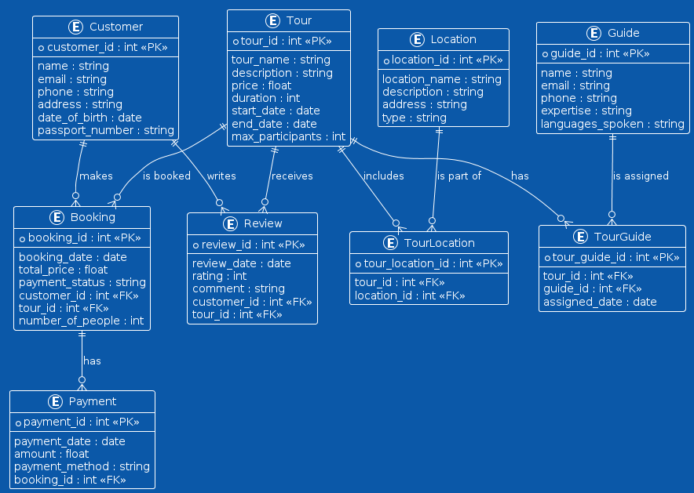

**Fig: ER diagram of our project.**

**Implementation**

**Setting up the development environment:**

**1. Install Web Server:** Apache was set up using XAMPP to create a local development environment.

**2. Database Setup:** MySQL was configured, and a new database named `tour_travel` was created.

**3. Initialize Version Control**: Git was initialized for version control to manage the codebase effectively.

**Front-End Development**

**1. HTML Structure:** Basic HTML templates were created for different pages like home, search results, booking details, and user account.

**2. CSS Styling:** Using CSS and Bootstrap to style the application and ensure responsiveness.

**3. PHP Structure:** Basic PHP structure was created for different pages.

**Back-End Development**

**1. Database Schema:** Designing the database schema using MySQL.

**2. User Registration and Login:** Implementing user authentication with PHP.

**3. Search Functionality:** Implementing search and booking functionalities.

**4. JavaScript for Interactivity:** Using JavaScript for backend.

**Testing and Deployment**

**1. Testing:** Performing unit tests, integration tests, and user acceptance tests to ensure functionality and usability.

**2. Deployment:** Uploading the application to a live web server and configuring the domain for public access.

By following this step-by-step implementation process, the Tour and Travel project was successfully developed, providing a robust and user-friendly platform for managing travel bookings.

**Results**

**Home page:**

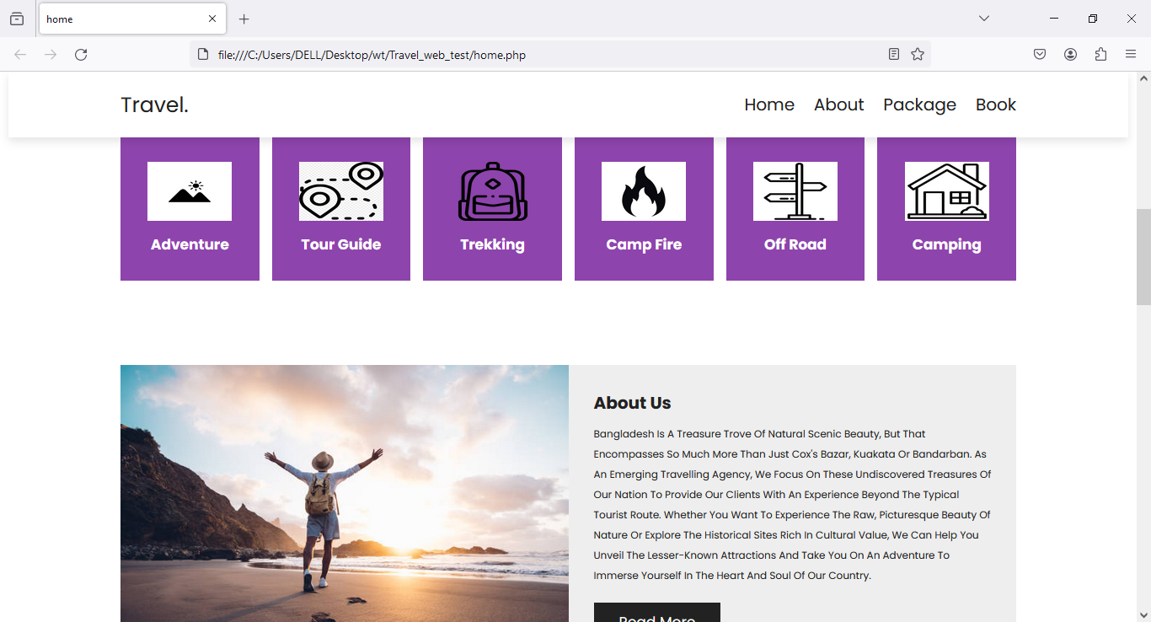

**About:**

**Packages:**

**More Information:**

**Book:**

**Payment Method:**

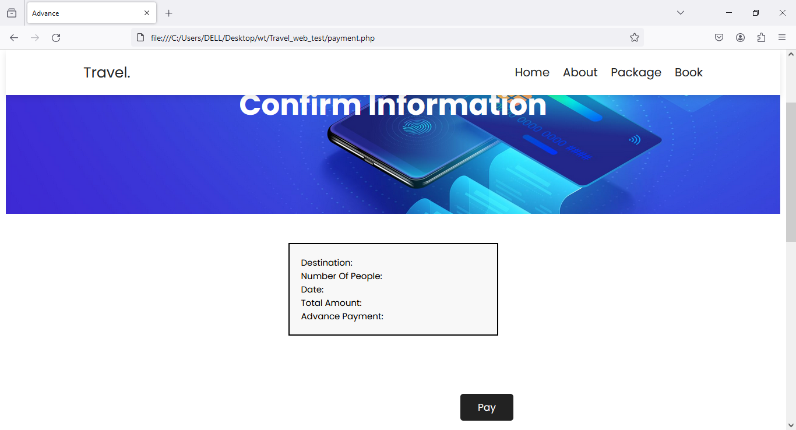

**Conclusion**

The Tour and Travel project successfully integrates multiple travel services into a cohesive and user-friendly web application. Utilizing HTML, CSS, JavaScript, and PHP, the platform offers a seamless booking experience for flights, hotels, and tour packages. The comprehensive development process, from initial planning and design to implementation and testing, ensured the creation of a robust system capable of handling various user interactions and administrative tasks. Key features such as real-time updates, secure user authentication, and a responsive interface enhance the overall user experience, making travel planning convenient and efficient. The challenges encountered during development were effectively addressed, resulting in a scalable and secure application. This project not only simplifies the travel booking process for users but also provides travel businesses with a powerful tool to manage their services. Ultimately, the Tour and Travel project stands as a testament to the effective use of web technologies in solving real-world problems and improving service delivery in the travel industry.

**References**

[1]. Welling, L., & Thomson, L. (2016). *PHP and MySQL Web Development*. Addison-Wesley Professional.

[2]. Duckett, J. (2014). *HTML and CSS: Design and Build Websites*. John Wiley & Sons.

[3]. Osmani, A. (2012). *Learning JavaScript Design Patterns*. O'Reilly Media.

[4]. Koch, D. (2016). *Bootstrap: Responsive Web Development*. Packt Publishing.

[5]. Bulger, P., & Levy, J. (2019). *Web Development with Node and Express: Leveraging the JavaScript Stack*. O'Reilly Media.

[6]. Beighley, L., & Morrison, M. (2009). *Head First PHP & MySQL: A Brain-Friendly Guide*. O'Reilly Media.

[7]. Freeman, E., & Robson, E. (2014). *Head First HTML and CSS: A Learner's Guide to Creating Standards-Based Web Pages*. O'Reilly Media.

[8]. Nixon, R. (2018). *Learning PHP, MySQL & JavaScript: With jQuery, CSS & HTML5*. O'Reilly Media.

[9]. Lara, J., & Zeid, A. (2020). *Beginning PHP and MySQL: From Novice to Professional*. Apress.

[10]. Marcotte, E. (2011). *Responsive Web Design*. A Book Apart.